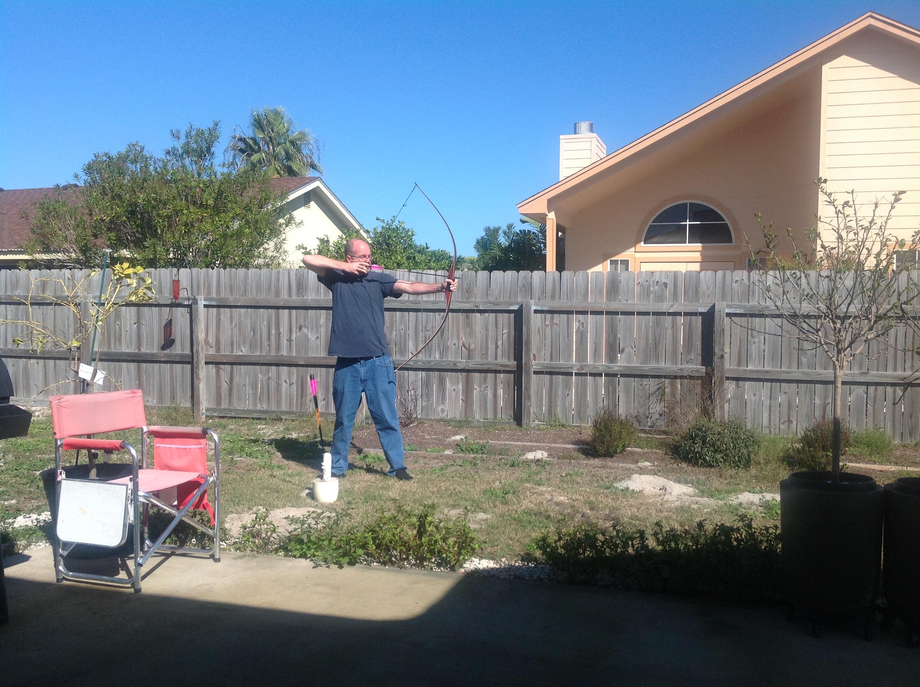 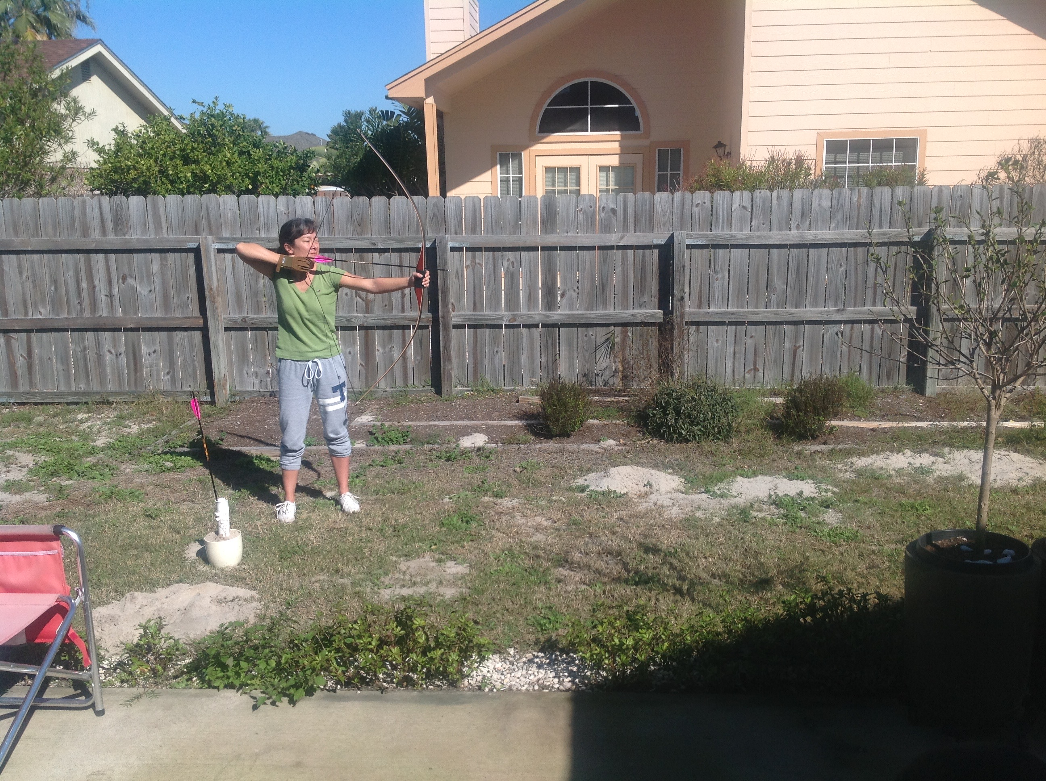

Paul’s Backyard Archery Patricia’s Backyard Archery

Longbow Lite Longbow

Corpus Christi, TX Corpus Christi, TX

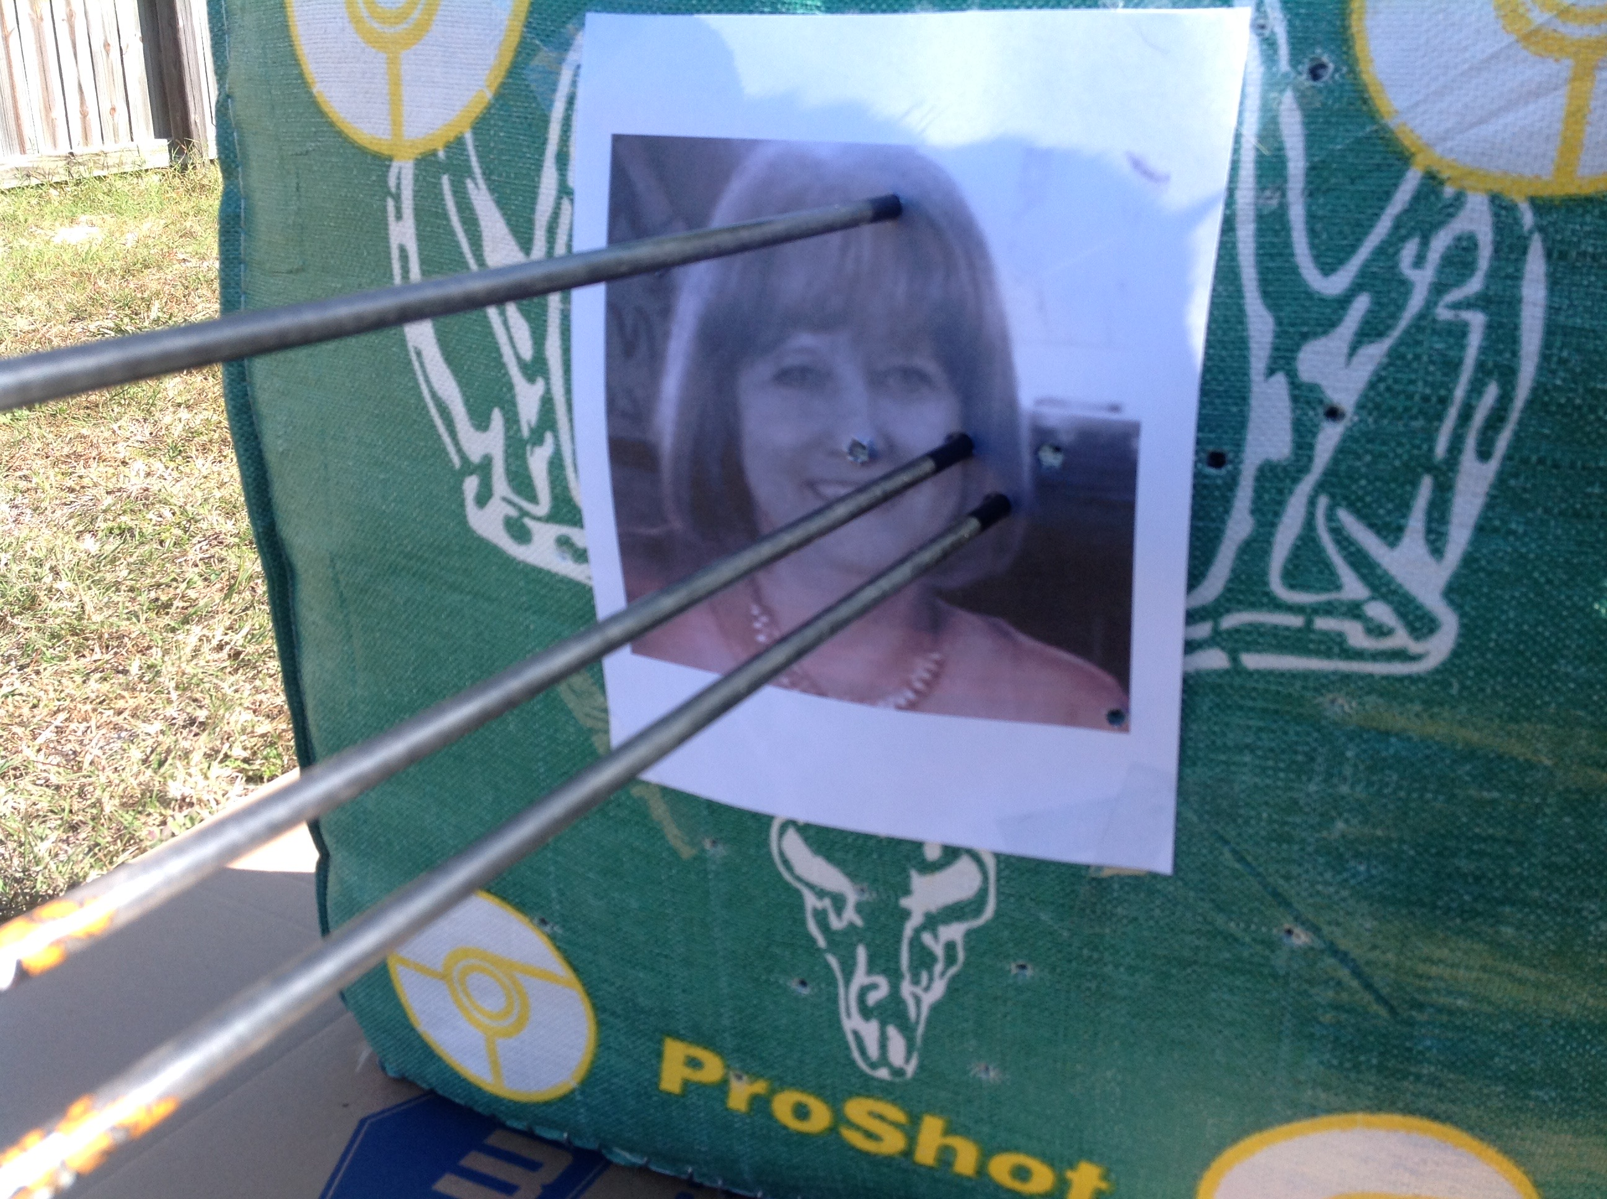

Our Backyard Target